RADIAN - RADar-based Intelligent Activity moNitoring
Matthew Blackwell
Mitch Hoffman
Wyatt Johnson

Validation and Execution Plans

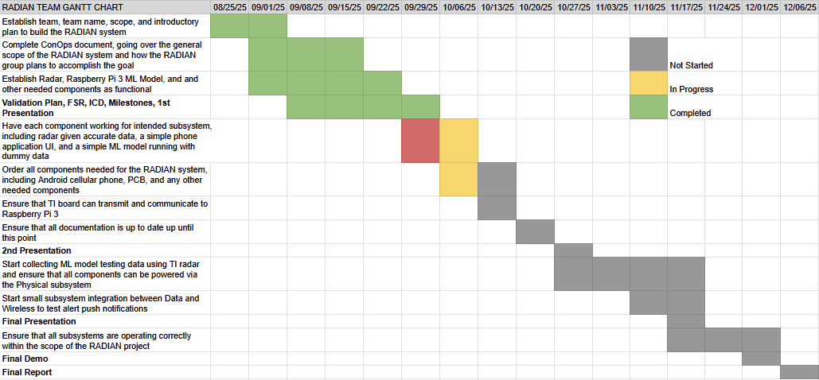
Figure 1: RADIAN Gantt Chart

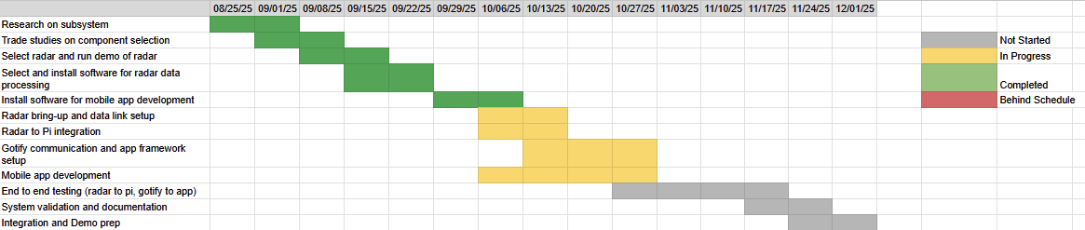
Figure 2: Wireless Gantt Chart

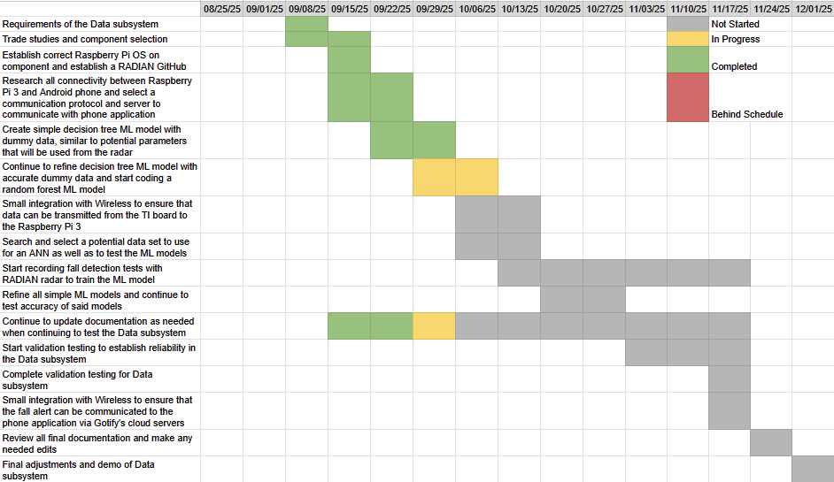
Figure 3: Data Gantt Chart

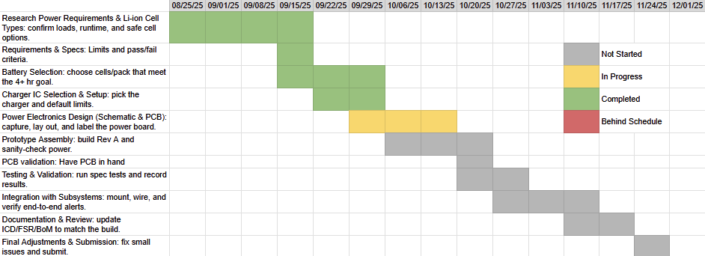
Figure 4: Physical Gantt Chart

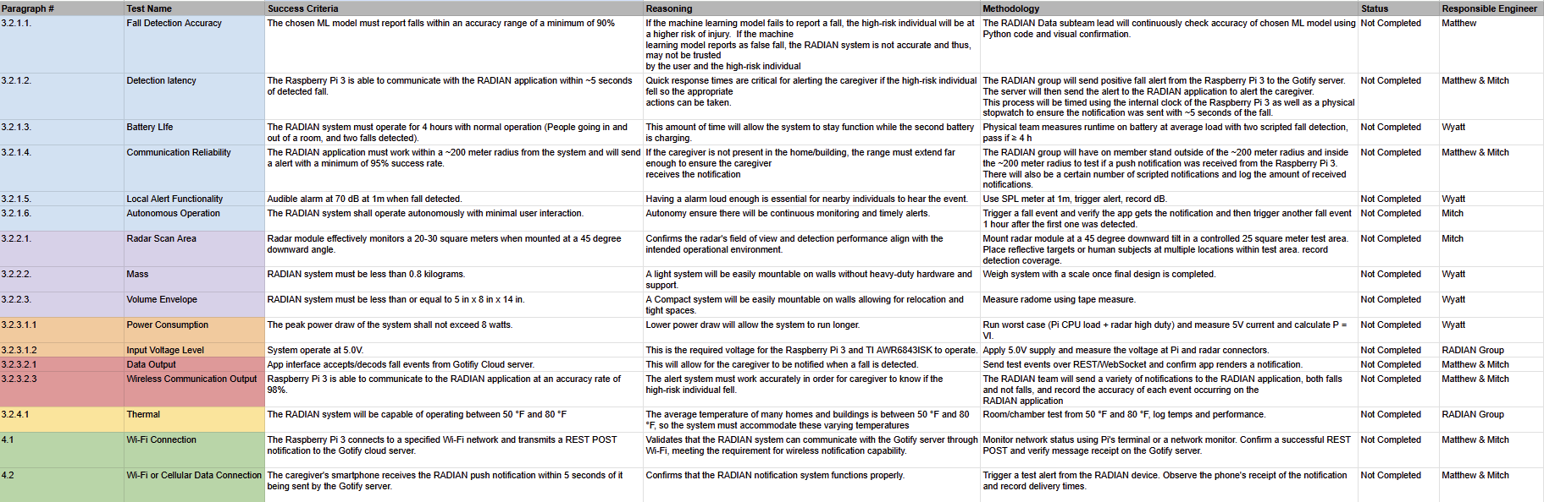
Figure 5: Validation Plan

